**John Studholme 1829 – 1903**

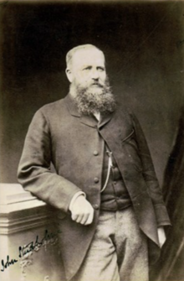

Thomas Morrin is the name most of us are familiar with. The original purchaser of 22,597 acres of Maori blocks in the Piako area which he named ‘Lockerbie’. In particular Motumaoho Block #2 on which the settlement of Morrinsville was established.

However, needing a cash injection to develop his estate he took on a partner, John Studholme in 1879. Studholme was a most interesting man, as early settlers often were. Determination and a certain fearlessness is rapidly apparent as you read his achievements and adventures in life. I have included a few of his exploits and land purchases below. When they laid out the plan for the settlement of Morrinsville in 1882 several streets were named after family connections.

He was born and educated in England and emigrated to New Zealand in 1851 at the age of 22 with his two younger brothers Michael and Paul. Together they bought farmland in Selwyn and Rakaia and once they had established these, they travelled to Australia to follow the Victorian gold rush. They returned in 1852 and having sailed in a ship that only went as far as Nelson they walked the 250 miles (560kms) back to their farm in Selwyn. Paul returned to England in 1858 and John & Michael went on to establish large stations in both the South and North Islands. Over the next 20 years they acquired by lease or purchase more that 910,000 (370,000 ha) and farmed extensively.

In 1854, both John & Michael Studholme walked from Lyttleton to Dunedin, some 250 miles (400kms) to purchase cattle. At this time there were no roads or bridged rivers. On arrival and having purchased their cattle, their cheque was refused as their was no bank yet in Otago to process it. After some discussion, John walked the250 miles back to Lyttleton to get cash and then returned at considerable personal risk with the cash and provisions. From Dunedin, after having paid for the cattle, the brothers returned home, undertaking the first crossing of the Waitaki River by settlers and stock. Unfortunately his brother Michael and partner in many acquisitons, had the dubious distinction of introducing wallaby to Canterbury in the South Island.

/P1

After initially living at Lyttleton, John and his wife Lucy (nee Moorhouse) yes, our street is named after her, they moved to Hororata and then to Michael’s homestead at Waimate when he moved to England for five years in 1864. On his return, they bought Merivale Manor then on the outskirts of Christchurch, from Lucy’s brother and sold Hororata to future Prime Minister John Hall (PM from 1879 – 1882).

In 1867 the Studholme brothers purchased 55,000 acres (22,000 ha) of flat tussock land south of Christchurch near Geraldine, known as Coldstream Estate for £35,000 (approximately $4m today) and John Studholme eastablished Coldstream as his primary residence. This was at the time, the smallest of the eight South Island Studholme estates. It was passed on to son Colonel John Studhome and is currently farmed by the 5th generation of Studholme’s.

1873 and John Studholme was on the move again, to Ruanui Station west of Taihape. First stocked with cattle, this proved unsuccessful due to many of the cattle going bush. Sheep were then brought in and as there were no established roads providing access to the station, wool was transported by rugged horse track to Napier a distance of 160kms, taking three weeks and accompanied by 60-70 horses. And also Cambridge a distance of 270kms. Another son, Joseph Studholme took over this station.

It is evident John Studholme had a passion for exploration and searching out the most promising land for farming. He explored much of the lower South Island, often alone and covering areas yet to be populated by Pakeha and much of that was on foot.

He took on some large leases and purchases which proved uneconomic particularly in the case of his half share with Thomas Morrin of the Lockerbie Estate. He expended a small fortune in stocking, grass seeding, fencing etc but the depression of 1885 – 1895 and the cost of draining and developing the land alongside low prices and high interest rates were ultimately ruinous. By 1886 they were both heavily in debt to the BNZ and the Land and Mercantile Association. By 1887 Morrin mortgaged his his interest in the estate to the Land and Mercantile Association and Studholme transferred his half interest to the BNZ. Lockerbie was eventually taken over by the Assets Realisation Board which was established by the Government to manage BNZ properties and gradually broken up for sale. Unlike Thomas Morrin, John Studholme appears to have had enough unencumbered property to escape bankruptcy.

John Studholme never resided in Morrinsville but he was an involved and important influence on its development and made inspection tours to the Lockerbie estate with Morrin over the time of their partnership.

/P2

……..

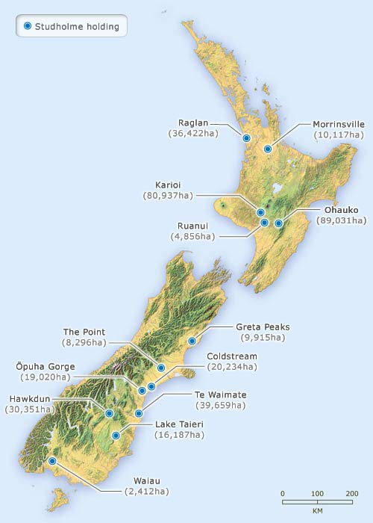

Jim McAloon, 'Land ownership - Centralisation after 1870', Te Ara - the Encyclopedia of New Zealand, http://www.TeAra.govt.nz/en/map/17926/studholme-family-land-holdings

Sources:Te Ara, Papers Past, Morrinsville Museum, Ruanui Station, Wikipedia, Beyond the Landing, Soldiers of the Mangateparu, Land of the Three Rivers

Penny Pickett

Morrinsville Museum /P3